## Practical1: Introduction and Contribution to Wikipedia

a)Description about Wikipedia and its features

Description about Wikipedia

Wikipedia is a free, open content online encyclopedia created through the collaborative effort of a community of users known as Wikipedians. Anyone registered on the site can create an article for publication; registration is not required to edit articles. The site's name comes from [wiki](https://whatis.techtarget.com/definition/wiki), a server program that enables anyone to edit Web site content through their Web browser.

Jimmy Wales and Larry Sanger co-founded Wikipedia as an offshoot of an earlier encyclopedia project, Nupedia, in January 2001. Originally, Wikipedia was created to provide content for Nupedia. However, as the wiki site became established it soon grew beyond the scope of the earlier project. As of January 2015, the website provided well over five million articles in English and more than that number in all other languages combined. At that same time, Alexa ranked Wikipedia as the seventh-most popular site on the Internet. Wikipedia was the only non-commercial site of the top ten Criticisms of Wikipedia include assertions that its openness makes it unreliable and unauthorative. Because articles don't include bylines, authors aren't publicly accountable for what they write. Similarly, because anyone can edit any article, the site's entries are vulnerable to unscrupulous edits. In August 2007, Virgil Griffiths created a site, [WikiScanner](https://whatis.techtarget.com/definition/WikiScanner), where users could track the sources of edits to Wikipedia entries. Griffiths reported that self-serving edits typically involved whitewashing or removal of criticism of a person or organization or, conversely, insertion of negative comments into the entry about a competitor. Wikipedia depends upon the vigilance of editors to find and reverse such changes to content.

Features of Wikipedia

**Basic features of a Wiki**

**You may not have realized, but you've probably already used a Wiki. The most famous example most people have engaged with is Wikipedia, the free internet encyclopedia that anyone can edit. While your company Wiki may not end up containing quite as many answers, the concept and functionality is the same.**

**Wikis can have a variety of uses and applications, but they usually share a few key functionalities. We'll walk you through each of these features using the Wiki in Backlog.**

* Link between pages
* Full page search.
* Hierarchical page display.
* A list of the most recently edited pages.
* Searching with tags.

b) Creating Account on Wikipedia

## Go to www.wikipedia.org and choose "English"

## 

## Click "Create account" on the upper right side of your browser

## 

## Enter your account information and the captcha, and click "Create Account"

## 

## Log in to your email and confirm your registration by clicking the link in the email

## 

## To log in in the future, return to the main page and click "Log in" in the upper right corner of your browser

## 

c) Creating your page on Wikipedia

Create a page

To contribute to a Wiki, you'll start by creating a page. All pages have a title and text. Unlike pages of a normal website, you won't need to know any code to contribute content here. You can write and format text on a Wiki page like you would an email.

When you're done, all you have to do is click “Submit” to save the page and it can immediately be read by anyone.

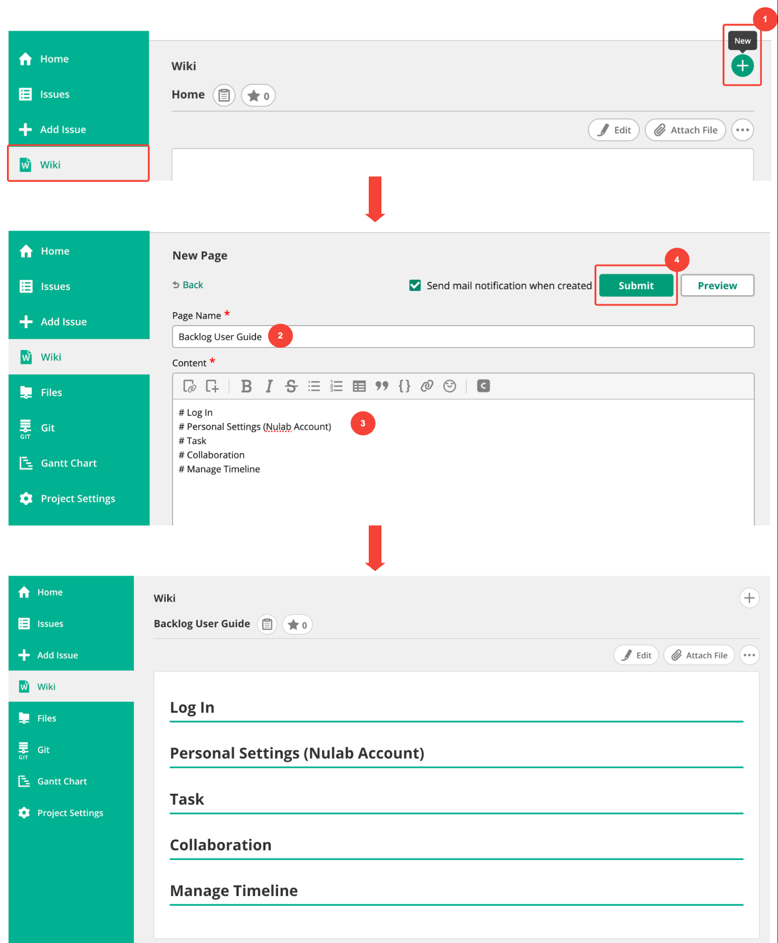

d) Editing your page on Wikipedia

## Edit a page

Published pages can be edited by anyone that reads them. If, for example, you notice that a page created by someone else contains inaccurate/outdated information, you can open the editing screen and correct that information directly. Just “Submit”, and the page's contents will update immediately.

